ONLINE PAYMENT FRAUD DETECTION USING MACHINE LEARNING

INTRODUCTION

Project Overview
Project Title:Online Payment Fraud Detection Using Machine Learning
Team ID: LTVIP2026TMIDS63406

Team Members:
    - Mannaru Prem Kumar
    - Anda Tharun
    - Chavva Tarun
    - Gaduputi Hima Varshini
This project is a web-based intelligent system that detects fraudulent online transactions using machine learning. The system analyzes transaction data such as amount, transaction type, sender and receiver balances to identify whether a transaction is fraudulent or safe.

Purpose
The purpose of this project is to:
    - Prevent financial fraud in online payment systems
    - Help banks and digital payment platforms identify suspicious transactions
    - Provide a fast, automated fraud detection solution using machine learning

IDEATION PHASE

Problem Statement
Online transactions are increasing rapidly, and so are online frauds. Manual verification is slow, costly, and inefficient. Fraudulent transactions cause huge financial losses to customers and banks. Therefore, there is a need for an automated system that can detect fraud accurately in real time.

Empathy Map Canvas
Users Feel Think Do Pain Points

Bank Customers
Fear of losing money
“Is my money safe?”
Perform online transactions
Fraud risk

Banks Concerned about losses
“How to detect fraud?”
Monitor transactions Manual
verification

Payment Apps
Want trust “System must be reliable”
Process transactions Security
breaches

Brainstorming
Different solutions were considered:
    - Rule-based fraud detection
    - Manual verification
    - AI-based fraud detection
Machine learning was chosen because it can detect hidden patterns and adapt to new fraud techniques.

REQUIREMENT ANALYSIS

Customer Journey Map
- User enters transaction details
- System sends data to ML model
- Model analyzes transaction
- System shows fraud or safe result

Solution Requirement Functional Requirements
    - Accept transaction details
    - Predict fraud or safe
    - Display result

Non-Functional Requirements
    - Fast response
    - High accuracy
    - Secure system

Data Flow Diagram
- User → Web Form
- Web Form → Flask Server
- Flask → ML Model
- Model → Prediction
- Prediction → User Interface

  - Technology Stack Layer Technology Frontend HTML, CSS Backend Python, Flask ML Model Scikit-learn Database CSV Dataset
Tools VS Code, GitHub

PROJECT DESIGN

Problem–Solution Fit
Online fraud is increasing. Our system provides an automated fraud detection tool, which fits the problem perfectly by improving security and reducing losses.

Proposed Solution
A web application integrated with a machine learning model that predicts fraudulent transactions using transaction details.

Solution Architecture
User → Web Page → Flask Server → ML Model → Result → User

PROJECT PLANNING & SCHEDULING
Phase Duration Data Collection 1 week Model Training 2 weeks UI Development 1 week Backend Integration 1 week Testing 1 week

FUNCTIONAL AND PERFORMANCE TESTING

Performance Testing
    - The system predicts results within seconds

    - Handles multiple transactions efficiently
    - Tested with multiple sample values

RESULTS
The model successfully classifies transactions as:
- Fraudulent
- Safe
The web interface shows the prediction clearly.

Output Screenshots
Screenshots include:
    - Home page
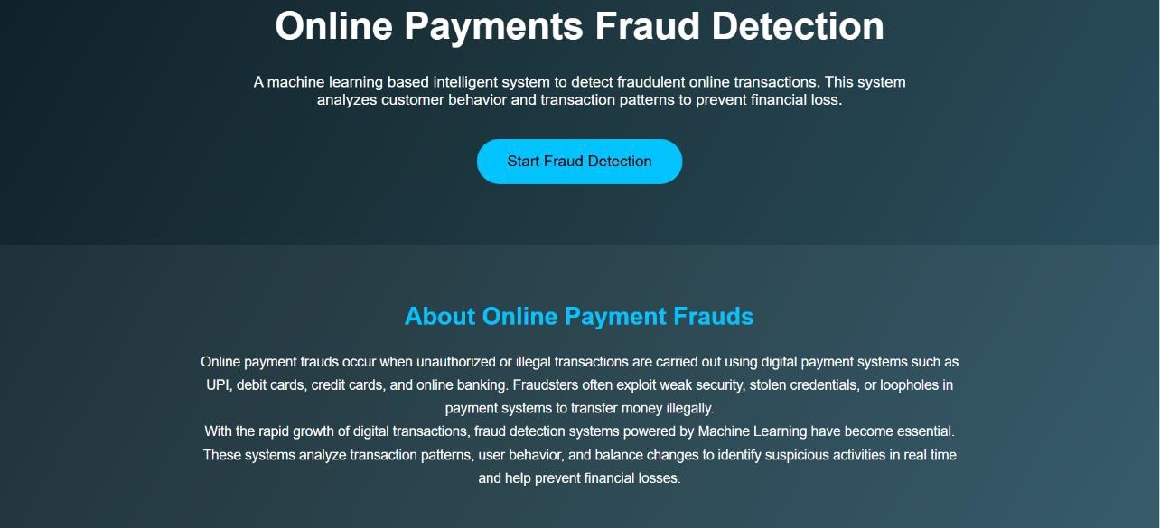
    - Fraud input page
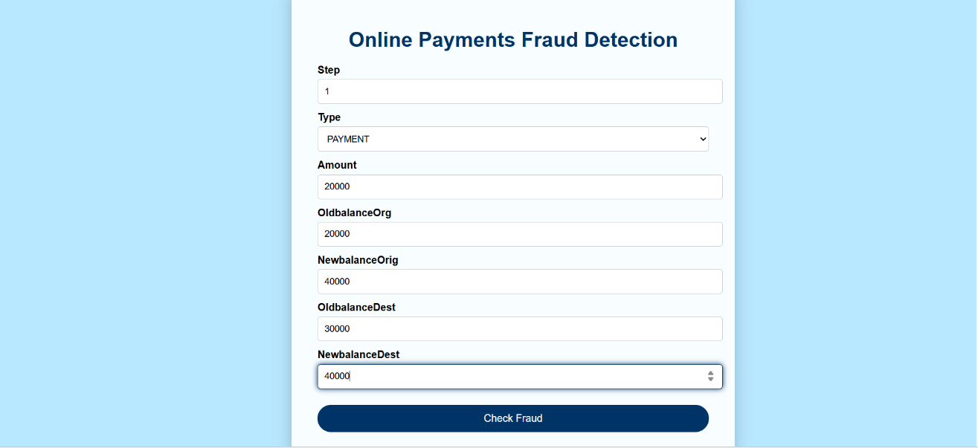

    - Fraud / Safe result page
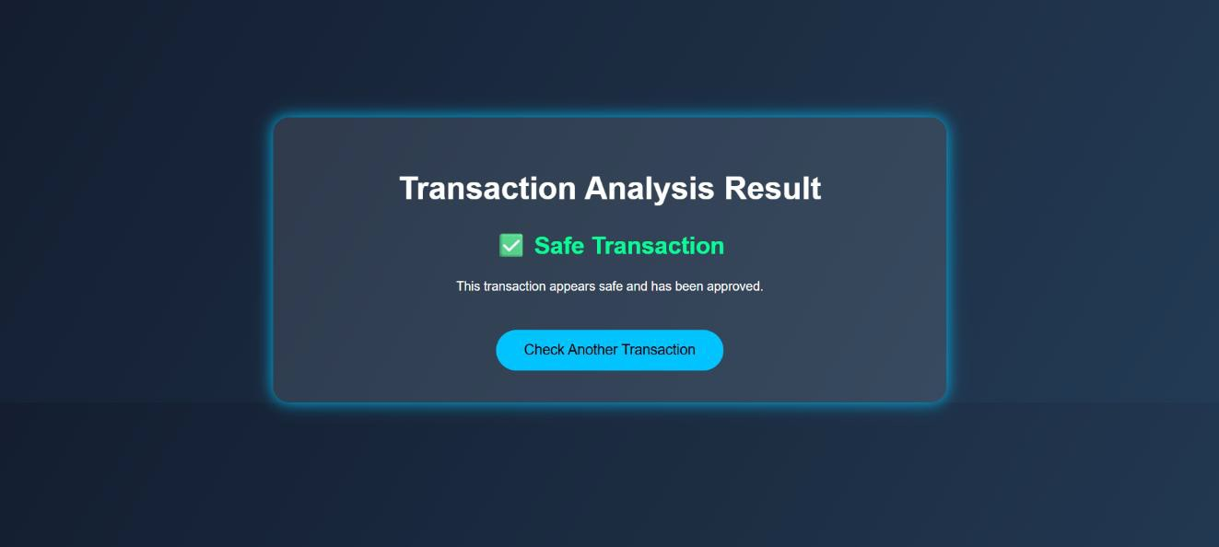
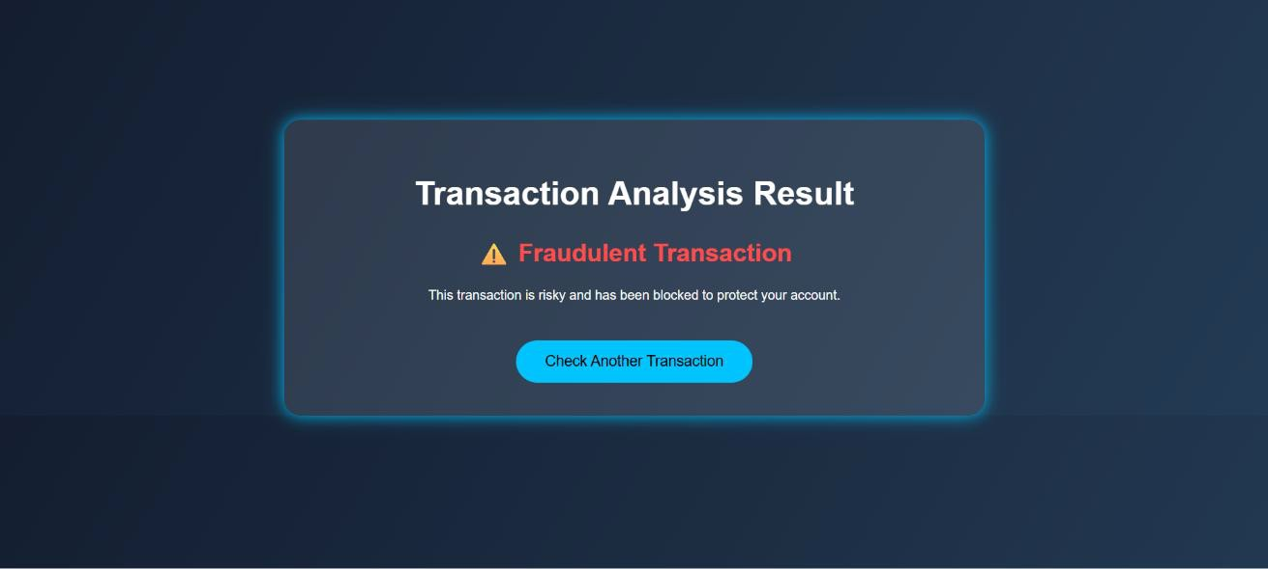

ADVANTAGES & DISADVANTAGES

Advantages
- Fast fraud detection
- Reduces financial loss
- Automated system
- Easy to use

Disadvantages
- Depends on dataset quality
- May give false predictions
- Needs retraining for new fraud patterns

CONCLUSION
This project provides an efficient solution for detecting online payment fraud. By using machine learning, the system improves transaction security and helps financial institutions reduce fraud losses.

FUTURE SCOPE
- Add real-time fraud detection
- Use deep learning models
- Add user login and dashboards
- Mobile app integration
- Cloud deployment

APPENDIX

Source Code:
Available in the project folder

Dataset Link:
Kaggle – Online Payment Fraud Dataset

GitHub Repository:
https://github.com/Prem-0427/online-fraud-detection
Project Demo: https://drive.google.com/file/d/1ojFNVaOuzDiyT2H6mQsM3cTnwBZLyHCU/view?usp=dri ve_link

